TANZANIA

With such a perfect location, perched on the edge of the African continent, and facing the Indian Ocean, Tanzania’s weather and climate leaves nothing to be desired. Warm and sunny days are followed by cool and balmy nights, and whether you are on safari on the Serengeti plains or enjoying the tropical, the temperatures are always welcoming and gentle. However, the sun-filled and beautiful days are not all that Tanzania has to offer. On the contrary, the country’s borders hold a vast number of people and tribes whose varied cultures and traditions make up the rich tapestry that is Tanzanian culture.

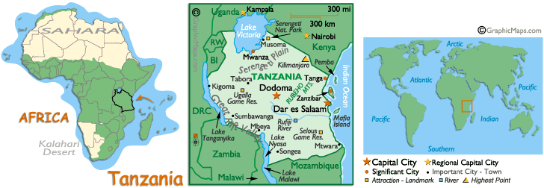

AIRPORTS:
There are 3 International airports: Dar Es Salaam (DAR), Kilimanjaro(JRO) & Zanzibar (ZNZ).

Dar es Salaam International (DAR) is 13km (8 miles) southwest of the city (journey time - 30 minutes).
To/from the airport: A shuttle bus service and taxi services are available to the city.
Facilities: Outgoing duty-free shop, car hire, post office, banking and currency exchange facilities, a bar and restaurants.

Kilimanjaro International Airport (JRO) is 50km (31 miles) from Arusha.
To/from the airport: Shuttle bus services and taxis are available to Arusha from Kilimanjaro. Facilities: Shops, post office, bar and restaurant.

Zanzibar Airport (ZNZ) is 8km (5 miles) from Kisauni.
Air India, Emirates, Kenyan Airways, South African Airways fly into DAR.

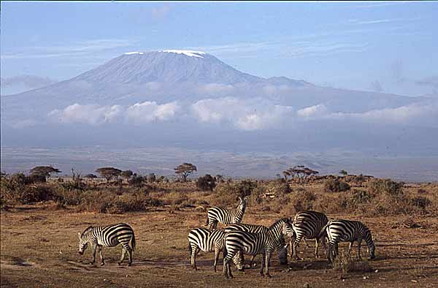

GETTING THERE:
By Air: The national airline is Air Tanzania (TC)
Most of the safaris in Northern Tanzania start and finish in Arusha. Kilimanjaro International Airport is about 40 miles from Arusha. Arusha is a great deal closer to Nairobi, the capital of Kenya, than it is to Dar-es-Salaam. The number of airlines and frequency of flights into Nairobi is much greater than those into Kilimanjaro International, and the prices more competitive.

By Road: Clients do have the option of arranging car transportation from Nairobi to Arusha and return.

GETTING AROUND:
By Air: By air: Air services have become the most significant form of internal transport for official and business travel. Small planes, from charter companies, fly to towns and to bush airstrips.
By Road: Traffic drives on the left. Tanzania has a good network of tarmac and all-weather roads connecting all major towns. Most minor roads are not all weather permitting, becoming impassable to all except 4-wheel-drive vehicles during the long rains in April and May. It is not advisable to drive at night because of wild animals, cattle, and goats on the road. There are often petrol shortages and spare parts for vehicles can be hard to find.
By Bus: Inexpensive buses connect most places; for example, there are services from Dar es Salaam to Arusha, Morogoro and Moshi. Visitors should avoid traveling by bus during the April/May rains.

LOCAL TIME:
Tanzania is 2.5 hrs behind India.

CURRENCY:
The Tanzanian Shilling is the local currency, but travelers checks and cash in US$ are recommended. The current exchange rate is approximately Tsh 850 = US$ 1. It is possible to change foreign currency at any Bureau de Chance, which generally give better rates than hotels and most banks.

DAILING Code: 00 255

HEALTH: A valid yellow fever vaccination certificate is compulsory and must be produced at the airport upon arrival

CLIMATE:
As Tanzania lies below the equator, the coolest months occur during the northern hemisphere’s summer, and all-year round the weather remains pleasant and comfortable.
June to October: temperatures range from around 10°C in the northern highlands to about 23°C on the coast. On the plains and the lower-altitude game reserves, are warm and mild. On the coast, these months are some of the most pleasant to visit, with balmy, sunny weather much of the day and cooling ocean breezes at night.
December to March: the days are hot and sunny with often not a cloud in the sky. Temperatures range from the mid-twenties to the low thirties throughout the country while visitors flock to the parks and beaches to escape the dreariness of late winter in colder climes. Clear sunny days are the norm in the northern highlands and the heat of mid-day is tempered by the golden light in late afternoon and the especially striking sunsets. In the game parks and central plains, the beautiful weather provides perfect opportunities for unhampered game viewing, and clear night skies offer perfect opportunities for star-gazing and romantic evenings in the bush.
Mid – March – end of May & November: Tanzania’s equatorial climate brings two seasons of rain each year: the masika, or long rains that fall from mid-March to the end of May, and the mvuli, or short rains, that come intermittently throughout November and parts of December, and sometimes stretch into early January.
CLOTHING:
Tropical clothing is worn throughout the year, but in the cooler seasons, from June to September, jackets and sweaters may be needed, especially in the evenings.
Pack lightweight, washable clothes plus a sweater for early morning game drives, a sunhat, sunglasses, and sunscreen. Long sleeves and trousers in light-coloured fabrics help discourage insect bites. Shorts for women are acceptable. Women should carry a wrap to cover legs in the village and towns as revealing clothes can cause offence.

EVENTS:
Great Migration: The precise timing of the Wildebeest Migration changes annually and it is a very unpredictable and spontaneous natural event. The calving season takes place in the Serengeti between the months of January and mid-March before the Wildebeest Migration begins heading towards the western Serengeti in June. The best time to see the migration is usually between June and August when the wildebeest congregate and prepare to cross the famous Grumeti River. There are a few excellent camps in the area where you can stay to witness this natural phenomenon. If you are in the Masai Mara you can expect the wildebeest to make their arrival as early as July, but they generally arrive between August and September and remain in the Mara between October and November. Between December and January the wildebeest gradually begin their migration back towards the Serengeti.

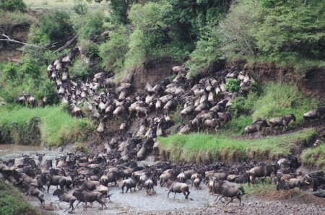

NATIONAL PARKS:
Tanzania's national parks extend over some 33,660 sq km (13,000 sq miles). In addition, there is the unique Ngorongoro Conservation Area, in which wildlife is protected and where the Masai tribes people also live and herd their cattle. There are also some 10 game reserves where government-approved hunting safaris operate under license and about 40 controlled areas where the hunting of game is controlled by a quota system.

ARUSHA NATIONAL PARK:
This park lies within the Ngurdoto Crater, a volcano that has probably been extinct for a quarter of a million years. This park is divided into 3 Areas. With the exception of the lions you will see all kinds of wildlife and different species of migratory birds. Visitors are able to see buffalo, rhino, elephant, giraffe and warthog.
When to visit: It is fine to visit here the whole year round. In April and May a 4 Wheel Drive is essential.
How to get there: From Arusha, a 30 mins drive takes you to the park, which is on the outskirts of the town.
Do Not Miss:
-the climb to Ngurdoto crater, in the forest inhabited by the Colubus Monkeys.
-The walk (with a warden) between Kitoto and the Mount Meru Crater.
-A picnic in one of the designated sites.

KILIMANJARO NATIONAL PARK:

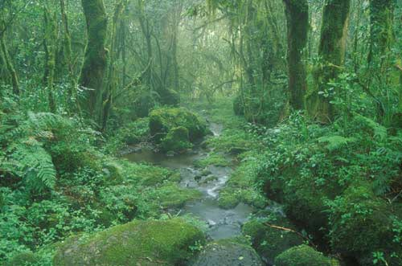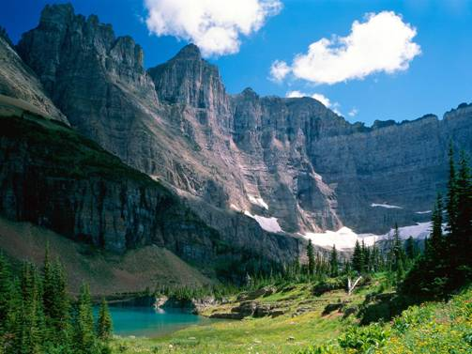

At 5895m (19,341ft), above the African plains, the magnificent solitary peak of Mt Kilimanjaro is the dominant feature of this national park, surrounded by a vast protected area. The lush rainforest on its lower slopes is home to a number of animals including elephant, buffalo, rhino, monkey, and leopard. The dormant volcano is remarkable in many ways, not only for its snow-covered peaks and glaciers rising out of a humid equatorial jungle, but it is the highest freestanding mountain in the world, a huge cone unattached to a mountain range, and Africa's highest peak. Africa's highest mountain is a major attraction for mountaineers. Expeditions must be accompanied by a guide and very warm clothes are required for the last section of the climb. The ascent takes about three days, allowing for rests at the three huts and a day or so at the final hut to acclimatize before tackling the final stage to the summit
There are no known indicators as to who might suffer from altitude sickness (fitness, age and experience are irrelevant) and the only cure is an immediate descent to lower altitudes
When to visit: Best time to visit is December to February – clearest and warmest conditions during this time. The best time to climb the mountain is between August and November.
How to get there: From Arusha, a 2-hrs drive, from Moshi a 40 mins drive.
Do Not Miss:
-your “climbing certificate”.
-A dish of grilled meat and bananas and a local beer “mbege” or “kilimanjaro” which you will enjoy.
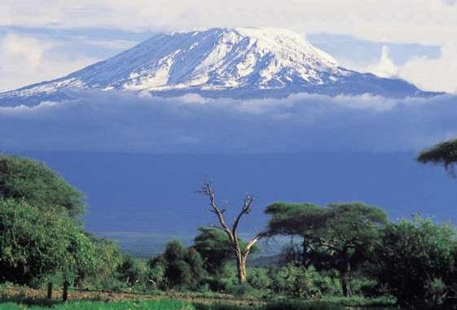
NGORONGORO CONSERVATION AREA:

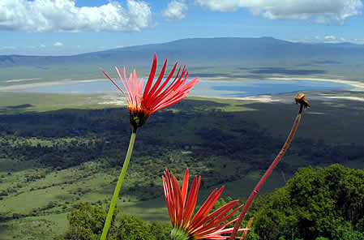

Rising high above the plains of the Serengeti, this vast protected area stretches from Lake Natron in the northeast (the breeding ground for east Africa's flamingoes) to Lake Enaysi in the south and Lake Manyara in the east. The area includes the still active volcano Ol Doinyo Lengai (Mountain of God), whose last major eruption was in 1983. The park's centerpiece is the Ngorongoro Crater, a collapsed volcano forming a crater that is 2000 ft deep, 20km (12.5 miles) in diameter, covering an area of 311 sq km (122 sq miles). The crater accounts for just one-tenth of the conservation area, which is home to almost every species of African plains mammal (except for the impala, topi and giraffe). The open grassland makes it easy to police, so it is also a stronghold for endangered species like black rhino and cheetah
It also has the densest population of predators in Africa. The rich birdlife includes flamingoes which are attracted by the soda content in Lake Magadi on the crater floor
When to visit: It is fine to visit here the whole year round. Rains are in April.
How to get there: From Arusha, a 4-hrs drive or 1 hr charters flight. From Manyara it’s a 2-hr drive.
Do Not Miss:
-A whole day in the crater where the show never stops.
-Tea time while watching the sunset above the crater.

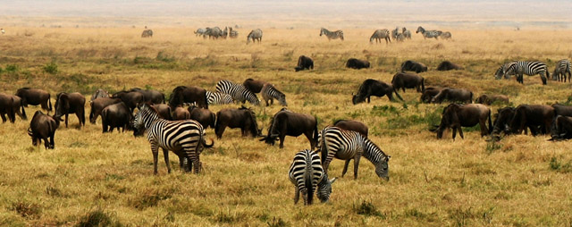

SERENGETI NATIONAL PARK:

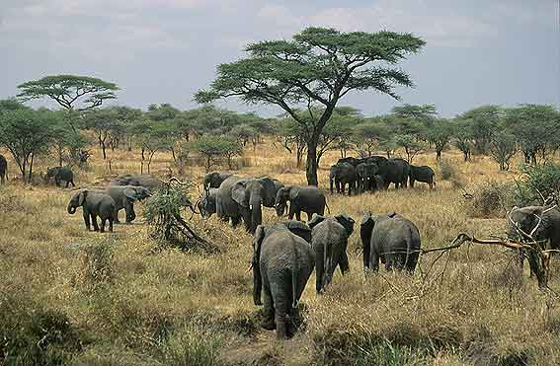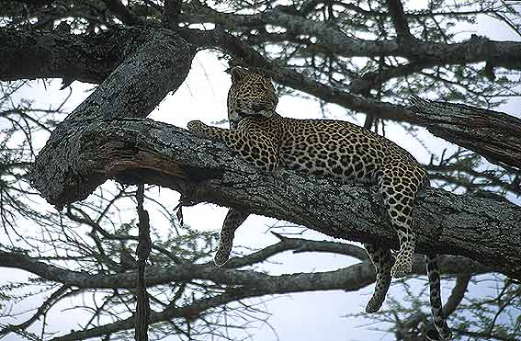

Meaning 'endless plains' in the Masai language, the Serengeti is Tanzania's oldest park and one of the world's best wildlife refuges, continuous with Kenya's Masai Mara Game Reserve to the north. The open plains are home to an estimated three million large mammals involved in seasonal migration, and together with the birds and smaller animals it has the largest concentration of wildlife in the world. The Serengeti is famous for the Great Migration, the most astounding occurrence in the animal kingdom that is known to humankind. During this time millions of hoofed animals, predominantly wildebeest, form one massive herd and leave the dry plains of Tanzania in search of greener grazing and water to the north. The season varies according to the rains, but the best time to witness the northward migration is usually from the beginning of June and again on their return in mid-November.
This is a plain-dwellers' stronghold of 14,763 sq km reaching up to the Kenyan border and claimed to be the finest in Africa. Here are 35 species of plain-dwelling animals, including wildebeest, zebra, gazelle, cheetah and lion and an extensive selection of birdlife.
When to visit: for the migration is from Nov to May in the south of the Park and from June to Oct in the West and to the North.
How to get there: From Arusha, a 5hrs drive or 1 hr 30 mins charter flight.
Do Not Miss:
-The big cats on the kopjes (huge granite rocks) which dominate the plains.
- Hundreds of crocodiles in the Grumeti River.

LAKE MANYARA NATIONAL PARK:

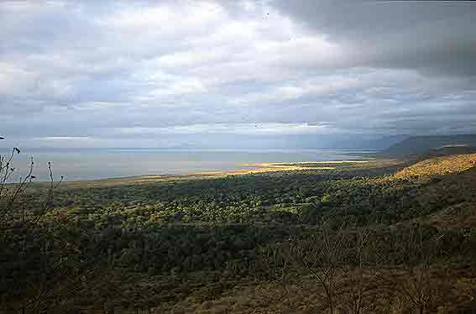

Located on the way to Ngorongoro Crater and the Serengeti, Lake Manyara National Park is well worth a stop in its own right. Lake Manyara’s famous tree-climbing lions are the main reason to pay this park a visit. The only kind of their species in the world, they make the ancient mahogany and elegant acacias their home during the rainy season, and are a well-known but rather rare feature of the northern park. In addition to the lions, the national park is also home to the largest concentration of baboons anywhere in the world -- a fact that makes for interesting game viewing of large families of the primates. Wildlife includes lions, herds of buffalo, elephant, rhino, impala, giraffe, leopard, zebra, bushbuck, reedbuck, waterbuck and blue and vervet monkeys. Manyara is also noted for its birdlife, particularly the flamingoes
How to get there: From Arusha, a 3-hrs drive or 1 hr by charter flight.

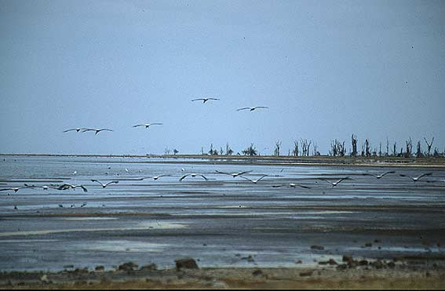

MIKUMI NATIONAL PARK:
This park, 1300 sq km in area, offers a chance to see lion, zebra, hippo, leopard, cheetah, giraffe, impala, wildebeest and warthog. A popular spot for visitors is the Kikaboga Hippo Pool. Although December to March is the ideal time for viewing at Mikumi, there are animals throughout the year.
TARANGIRE NATIONAL PARK:
Only 130km from Arusha and 8km off the Great Cape to Cairo road, it is nonetheless an area which compares favorably with the Serengeti in terms of wildlife density.
RUAHA NATIONAL PARK:
Tanzania's second-largest and wildest park and the world's largest elephant sanctuary, Ruaha is located 128km (80 miles) from Iringa in the Southern Highlands along an all-weather road. The park affords views of unparalleled scenery along the Ruaha Gorge, with many sightings of antelope. Iringa is also connected with Dar es Salaam and other centers by air and bus service. The best time to visit is from July to November.
SELOUS GAME RESERVE:
The Selous Game Reserve in southern Tanzania covers an area larger than Switzerland (about one-sixth of Tanzania's land surface), making it one of the biggest in the world, with a massive elephant population. There is also a high concentration of stalking lions and other game. UNESCO declared the game reserve a World Heritage Site in 1982.
]
GOMBE STREAM NATIONAL PARK:
This park is near Kigoma on the shores of Lake Tanganyika and is the home of about 200 chimpanzees, more easily seen here in their natural habitat than anywhere else in the world. This is the place where Jane Goodall devoted her life to recording chimpanzee ethology in a 37-year study.
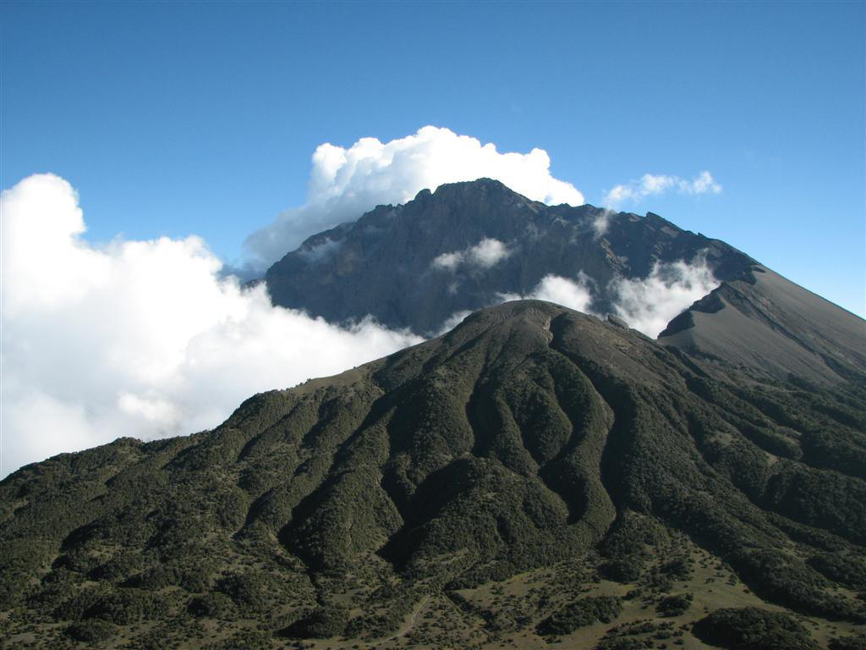

OTHER NATIONAL PARKS:
These include Katavi, Mahale Mountains, Rubondo Island and Udzungura Mountains. There are also marine parks at Kilwa Reserve, Latham Island Reserve, Rufigi Delta and Tanga Coral Gardens.

THE COAST:
DAR ES SALAAM:
Once the capital city, the major port of Dar es Salaam is the natural starting point for trips in Tanzania. It is near the island of Zanzibar. Parts of Dar es Salaam have a tranquil air that belies industrial and commercial growth. Further attractions include the National Museum, housing the skull of Nutcracker Man; Observation Hill, which contains the campus and facilities of the University of Dar es Salaam; and the Village Museum, with exhibits of traditional housing and crafts.
Excursions
The fishing village of Msasani, 8km (5 miles) from Dar es Salaam, contains tombs dating back to the 17th century. Further south, at Kilwa Klsiwani, there are ruins of Portuguese and Arab architecture. Many beautiful beaches are within easy reach of Dar es Salaam, such as those at Kunduchi, Mbwa Maji and Mjimwena.
-Kunduchi, 24km (15 miles) north of the city, is a fishing village with nearby ruins of Persian tombs and mosques.
-Mbudya Island is an uninhabited island forming part of a protective coral reef which is a good place for diving, snorkeling and fishing.
-Sinda Island, some 14km (9 miles) off Dar es Salaam, also offers facilities for snorkeling and shell fishing.
-A 72km drive north of Dar es Salaam is Bagamoyo, a one-time slave port and terminus for the caravans. This tiny township is the nearest mainland point to Zanzibar and possesses sandy beaches set in a beautiful bay. Livingstone's body rested in the tiny chapel of the convent here on its way back to London. The town mosque and Arab tombs date from the 18th and 19th centuries.
Some 5km (3 miles) to the south is the village of Kaole, near which are the ruins of a mosque and pillars believed to be 800 years old.
To the north of Bagamoyo, near the Kenyan border, is the country's second port, Tanga. From here, the visitor can drive to the beautiful Usambara Mountains and Moshi on the slopes of Mount Kilimanjaro.
ZANZIBAR & MAFIA ISLAND:
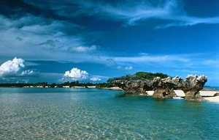

Tanzania has 804km (503 miles) of coastline with superb beaches. Scuba-diving and snorkeling are particularly good around the islands of Mafia and Zanzibar, which have recently gained a high reputation amongst divers. Offshore from Zanzibar are several islands ringed with coral reefs. Both Mafia and Zanzibar are also renowned for excellent deep sea fishing. There are numerous resorts and operators offering diving and fishing excursions. The main fishing season is from September to March. Dolphin safaris and Dhow trips are also popular, although a law now prohibits tourists from traveling in dhows from the mainland to Zanzibar.
ZANZIBAR:
The island of Zanzibar, once the metropolis of East Africa, variously ruled by Shirazi Persians, the Portuguese, the Omani Arabs and British colonials, is only 20 minutes' flight from Dar es Salaam (ferries are also available). Otherwise known as the 'Spice Island', Zanzibar's golden age was under the Omani Arabs in the early 19th century. By the middle of the century, it had become the world's largest producer of cloves and the largest slave-trading post on the African eastern coast. Zanzibar's old Stone Town, a UNESCO World Heritage Site, is a labyrinth of narrow, winding streets lined with exotic shops, bazaars, colonial mansions, mosques and squares.

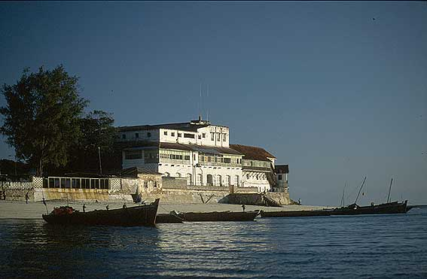

The visitor can still see the house where Dr Livingstone lived, as well as that used by Burton and Speke. The Anglican Cathedral Church of Christ stands on the site of the Old Slave Market, off Creek Road, while on the seafront are the palace of the former sultan and the towering Beit-el-Ajaib (The House of Wonders). Zanzibar is a fascinating place with palaces, forts, stone aqueducts, and baths; its history as a cosmopolitan center of trade gives it a unique atmosphere. The guided Spice Tours are recommended. Within the vicinity lie many offshore islands ringed with coral reefs, the most famous and most visited being Changuu Island (also known as 'Prison Island'). There are also many superb beaches, particularly on the east coast.
Note:
Visitors to Zanzibar should observe Muslim conventions regarding dress when away from the beach.
MAFIA:
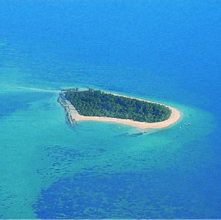

Some 40 minutes' flight south of Dar es Salaam, the island of Mafia is renowned for big-game fish as well as being a unique marine park. Powerboats and tackle are available for hire.
Mafia's Chloe Bay is part of a protected marine park, with an unbroken reef running the length of the island. There are also many secluded beaches

SHOPPING:
The Tourist areas and hotels sell a wide range of souvenirs, jewelry, and trinkets. Don't be afraid to bargain at roadside stalls (Your driver/ guide will advise you where to shop and on a reasonable price). The most popular souvenirs are wooden carvings, curios, and a famous love stone, which is the well-known gemstone "Tanzanite" which is all widely sold at souvenir shops.
What Not to Buy: Please avoid purchasing wildlife products such as ivory and skins as the market created by these purchases encourages poaching and terrible injuries to the animals themselves. Woodcarvings too, should be checked to ensure that the material comes from a renewable, sustainable source.

FOOD:
Most hotels serve local Tanzanian food while the major hotels offer Western and other international food.
Table service is normal in restaurants. Bars generally have counter service. Tanzania is a secular state and alcohol is not prohibited. Zanzibar's population is predominantly Muslim. Alcohol is available in some tourist hotels and restaurants, but should not be drunk in public.
National specialties:
• Seafood such as prawns and lobsters.
• Tropical fruit such as coconuts, pawpaws, mangoes, pineapples and bananas.
• A good lager, Safari, is produced locally.
• Konyagi is a popular gin.
• A chocolate and coconut liqueur called Afrikoko.
• A wine called Dodoma, which comes in red or rosé

Indian Restaurants in Tanzania

Arusha
Khan’s Grill
Barabara Ya Mskiti (Mosque St near the market)
Arusha

Dar es Salam
The Retreat, between Kisutu and Jamhuri Streets, is open from Tuesday to Sunday and serves excellent vegetarian food and is a popular place with locals and ex-pats. Try a Thali.
K Tea Shop just off of Libya Street, has great kebabs other Indian snacks.
Istana serves an excellent buffet; cuisines change per day of the week.
Alcove on Samora avenue is the place for Indian and Chinese vegetarian food.

RECOMMENDED HOTELS:

DAR ES SALAM
Movenpick,
Kilimanjaro Hotel
Kempinski
Holiday Inn
White Sands Hotel

NGORONGORO
Ngorongoro Sopa Lodge
Crater Hotel
Ndatu Lodge
Highview Hotel
Ngorongoro Wildlife Lodge

Serengeti
Serengeti Sopa Lodge
Grumeti River Camp
Klein’s Camp
Serengeti Safari Serena Lodge
Serengeti Wildlife Lodge

Lake Manyara
Lake Manyara Serena Lodge
Lake Manyara Tree Lodge
Lake Manyara Hotel

Tipping: Not generally encouraged, though waiters and porters in hotels and restaurants may expect to be tipped.
NIGHTLIFE:
In Dar es Salaam, there are several nightclubs, cabarets and cinemas. Generally, the nightlife centers are in the top tourist hotels and restaurants.

